**Real-Time Communication System Powered by AI for Specially Abled**

# 

***Submitted by :***

***TEAM ID:- PNT2022TMID26077***

***SANJAY P (2019PITEC254 PIT)***

***SANJAIRAJ M (2019PITEC252 PIT)***

***RUPESH V (2019PITEC247 PIT)***

***RITHWIN PRASEED (2019PITEC246 PIT)***

Real-Time Communication System Powered by AI for Specially Abled

**Abstract**

In this paper, we discuss a stand-alone technology that would make it simple and fluid for hearing-impaired and normal individuals to converse with one another. We provide an application for automatically translating visual data into text in real time while using image processing to recognise American Sign Language. Video footage from a digital camera or camera application will be used to create a real-time hand gesture detection system after which the hand position and location will be tagged and isolated via cropping. The hand motions will then be identified by image processing and compared to a gesture database that has already been created, which will be utilised for text conversion on the screen. Additionally, the programme allows regular users to write the text down and exhibit the corresponding animation of hand motions. This system does textual representation and real-time recognition of American Sign Language, producing more accurate results in the shortest amount of time. It won't just help the specially abled; it may also be applied in a number of different technological contexts.

Additionally, this method gives users the freedom to study American Sign Language at their own speed, whenever they want, anywhere—at home or at work.

1. **Introduction**

* **Project Overview**

By discussing their ideas, opinions, and experiences with others around them, people come to know one another. There are several methods to do this, but the gift of "Speech" is the finest. Speech allows everyone to communicate their ideas and comprehend one another quite well. It would be unfair to ignore those who are denied this wonderful gift: individuals with disabilities. In these circumstances, sign language has traditionally been used using the human hand.

The most common issue for those with hearing/speech impairments is being unable to communicate with others. They utilise Sign Language to communicate with others in order to express their thoughts or feelings (SL). Sign language (SL) is a prominent way of communication mechanism utilised regularly by persons who are deaf or hard of hearing. This nonverbal language employs hand motions as well as occasional face gestures.

With the advancement of technology, some form of device or instrument that can mediate between hard-of-hearing people and normal people is necessary, so that they may easily interact with each other without the need for a third person as an interpreter.

* **Purpose**

In order to communicate with regular people, the project intends to create a system that translates sign language into text that is legible by humans. A convolution neural network is being used to build a model that is trained on various hand motions. A web application utilising this concept is created. With the use of this software, persons who are deaf or dumb may communicate using signs that are translated into language that is intelligible to others

1. **Literature Survey**

* **Existing Problem**

There are three main ways that hearing loss might impact a person:

1. Less access to school and employment owing to communication problems

2. social withdrawal brought on by limited access to services and communication challenges

3. emotional issues brought on by a decline in confidence and self-worth.

**Points to keep in mind**

* At least 700 million individuals will need hearing rehabilitation by 2050, when it is predicted that approximately 2.5 billion people would have some degree of hearing loss.
* Due to dangerous listening habits, almost 1 billion young individuals are at risk of developing permanent, preventable hearing loss.
* **Existing Solutions**

Few existing solutions for these kind of problems are as follows

* *The use of technology*

Technology, such as laptop or smart phone, is one of the simplest methods to connect. Both a hearing person and a deaf person can type out what they wish to communicate. Additionally, a blind person can use voice recognition software to translate their speech into writing, which a Deaf person can subsequently read.

* *The use of interpreter*

If the deaf person is fluent in sign language and a sign language interpreter is present, communication is made easier. Through the interpretation, the deaf person and the blind person may converse. The interpreter can say what has been stated to the blind person after the deaf person has used sign language, and they can also translate any spoken words from the blind person into sign language for the deaf person.

* **References**

**1. TITLE:**

Innovative study of an AI voice based smart device to assist deaf people

**AUTHOR**: Dhaya Sindhu Battina

**YEAR:**

2021 Assistive technology consists of a wide range of hardware and software tools that enable a person to receive information in the format that suits their needs best. These Various technology may be available to the deaf.. . Many items, including cochlear implants, loop systems,accessibility, FM technology, and assistive listening devices,visual warning systems, videophones, and much more . Recognizing the worth and boundaries of different assistive devices can be advantageous for both. Artificial intelligence (AI) enables computers to learn from existing experiences, adapt to new information, and perform tasks that are similar to those carried out by humans . The vast majority of artificial intelligence applications that users know of today – ranging from chess playing robots to self-driving vehicles – are primarily reliant on deep learning and computational linguistics.Computers may be taught to do particular jobs by processing huge quantities of data and detecting trends in the data. This is accomplished via the use of various technologies Machine learning technologies have the potential to substantially reduce the communication obstacles that deaf or hearing-impaired persons have when interacting with other groups, thus promoting social inclusion for these individuals. Recent advancements in both sensing technology and artificial intelligence algorithms have opened the way for the creation of a broad array of applications aimed at meeting the requirements of the deaf and hearing-impaired populations.

**2. TITLE:**

Communication system for deaf and dumb people

**AUTHOR:** Shraddha R. Ghorpade, Prof. Surendra K. Waghmare2

**YEAR:**

2019 People with disabilities are having a difficult time keeping up with the rapidly evolving technology, which is one of the major issues that our society is dealing with. For those with disabilities, having access to communication tools has become crucial. typically deaf and stupid people use sign language to communicate, but they struggle to do so with non-sign language users language. Information is the main topic of communication between normal and deaf individuals using sign language, which is expressive and natural. So that we can converse with them and comprehend what they're saying, we need a translation. A language translation technology converts common sign language into voice, enabling regular people to communicate with one another. When it comes to communicating with other people,sign language (SL) is the primary method of communication for hearing-impaired individuals and other groups. It is conveyed via both manual (body and hand movements) and non-manual (face expressions) characteristics. All of these characteristics are combined to create utterances that communicate the meaning of words or statements . Understanding and being able to record and comprehend the relationship between utterances and words is critical for the Deaf community's ability to lead us toward a time when automated translating between utterances and words is possible .In recent years, researchers have recognized the need for the development of sign language technology to assist hearing-impaired individuals in communicating and socially integrating into their communities. Even though the advancement of such innovations can be extremely difficult owing to the inclusion of multiple sign languages and a scarcity of large annotated datasets, recent advances in artificial intelligence and machine learning have made significant strides towards automating and improving such systems. Keywords: Image Processing, Human Computer Interface (HCI).

**3. TITLE:**

Educational Status of Differently Abled Persons and Developed Policies in India

**AUTHOR:** Chiranjit Majumder

**YEAR**:

2019 April One of the socially created phenomenon is basically Disability. The fact is that many children and adults suffered from disabilities excluded from mainstream education benefits. Disabled persons are segregated from education system because of social negligence and absence of support system in the home and inadequacy of sufficient facilities in schools particularly. However, education is the most important medium for social, economic and political transformation. Socialization of children with disabilities (CWD) through education receives an unremarkably important roles in societies such as India where social exclusion of Physically Challenged Persons (PCPs) is significant. Indisputably, the literacy level of Physically Challenged Persons (PCPs) is very low in India. Very poor educational outcomes for children with disabilities remain in developing countries specially. Most of disabled persons do not get the full benefits of education. However, some policies in India has started to display some concern for Physically Challenged students. Education is utmost significant to lift up the socio-economic status of PCPs. But education of disabled persons has not received adequate intentness and resources that it requires. Physically Challenged Persons (PCPs), few who are enrolled in schools are not given equal opportunity for middle secondary and higher education levels. Many Disabled persons are educated but they do not get any work for earning in our society. However, in India the existing situation began to change. Indian policies has started to understand as for all people that education is essential for children and adults with IJTSRD21762 International Journal of Trend in Scientific Research and Development (IJTSRD) @ www.ijtsrd.com eISSN: 2456-6470 @ IJTSRD | Unique Paper ID - IJTSRD21762 | Volume – 3 | Issue – 3 | Mar-Apr 2019 Page: 342 disabilities in itself and helpful for participating in employment and other sites of social activity. The Ministry of Human Resource Development (MHRD) has initiated various programmes to give educational opportunities to PCPs in an environment that is inclusive (Ghoshal S.K., 2018). Government of India also understands the needs of appropriate vocational training skills to make them self faithful and productive members of society. But, the scheme coverage has stayed limited. Non Governmental Organizations (NGOs) has a biggest role to improve the life of disabled persons in our society. Educational Status of Disabled Persons in India India is the world’s largest democracy. India has a countless challenges for ensuring access to education for over all 200 million (20 Cr) children aged 6 to 13 years. As per 2011 National Census, 1.05% of school going children have a problem like disability (2.13 million = 21 Lakhs 30 Thousand); of these 28% (5 Lakhs 88 Thousand) are not accessing school. Particularly 44% of disabled children are not accessing school have complex and multiple forms of activity limitations and functioning difficulties (Bakhshi et al, 2017). Education is an fruitful tool for socio-economic empowerment which can develop the career of specially disabled ones. disabilities in itself and helpful for participating in employment and other sites of social activity. The Ministry of Human Resource Development (MHRD) has initiated various programmes to give educational opportunities to PCPs in an environment that is inclusive (Ghoshal S.K., 2018). Government of India also understands the needs of appropriate vocational training skills to make them self faithful and productive members of society. But, the scheme coverage has stayed limited. Non Governmental Organizations (NGOs) has a biggest role to improve the life of disabled persons in our society. Educational Status of Disabled Persons in India

* **Problem Statement**

The solution to the issue that the speech and hearing challenged encounter is outlined in this research. The goal of the research is to create a system that narrows the communication gap between speech- and hearing-impaired people and the rest of society.

1. **Requirements**

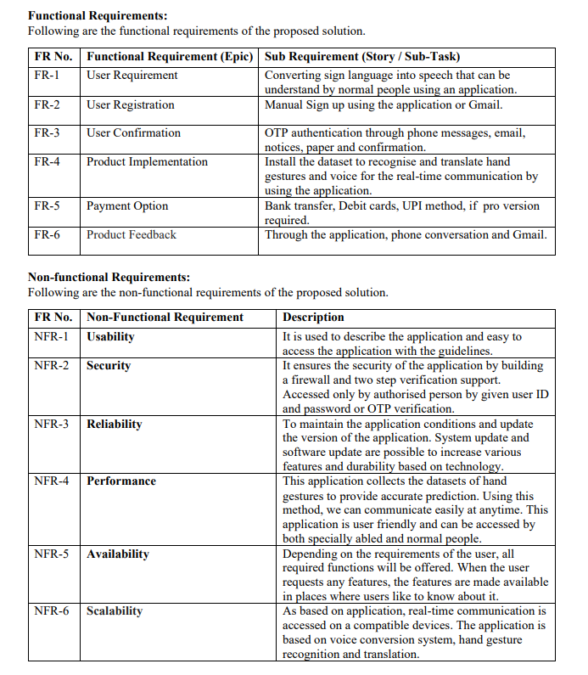

1. **Project Design**

* **Data Flow Diagrams**

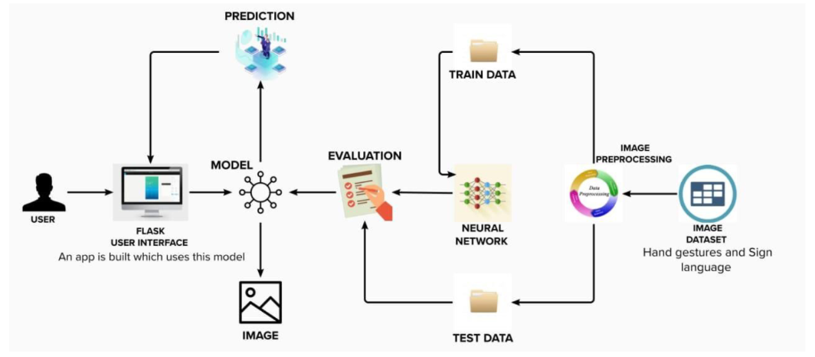

* **Block Diagram**

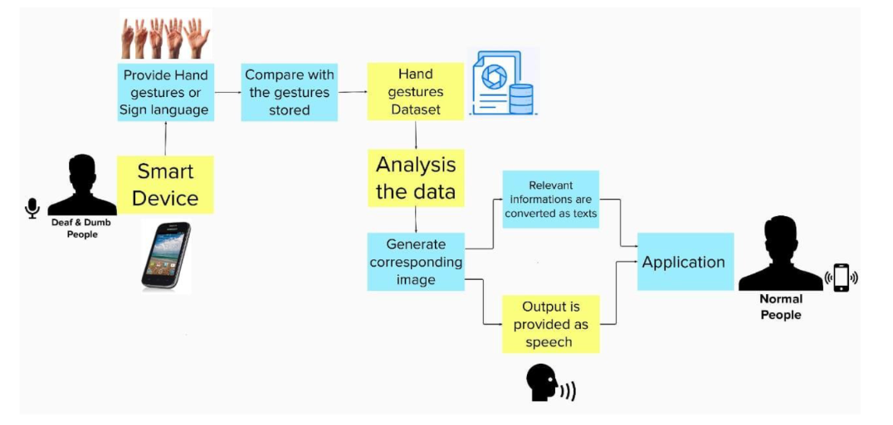

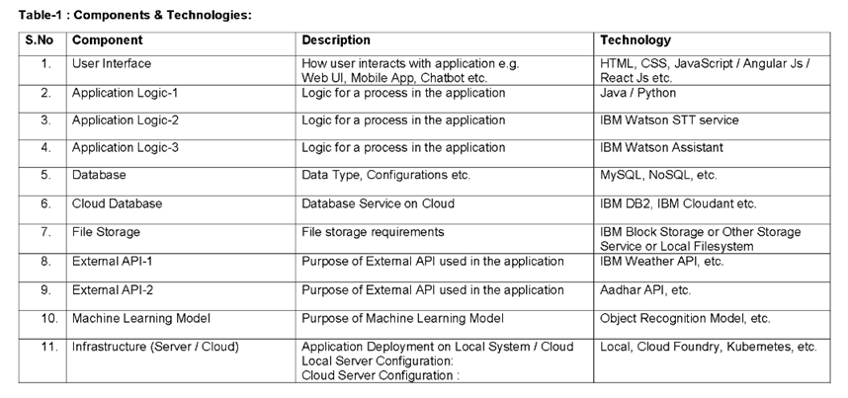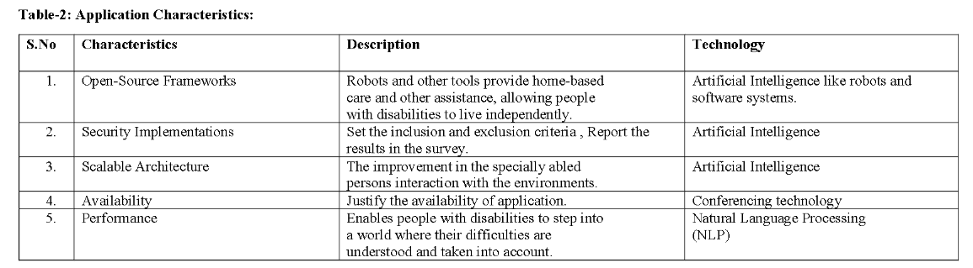

* **User Stories**

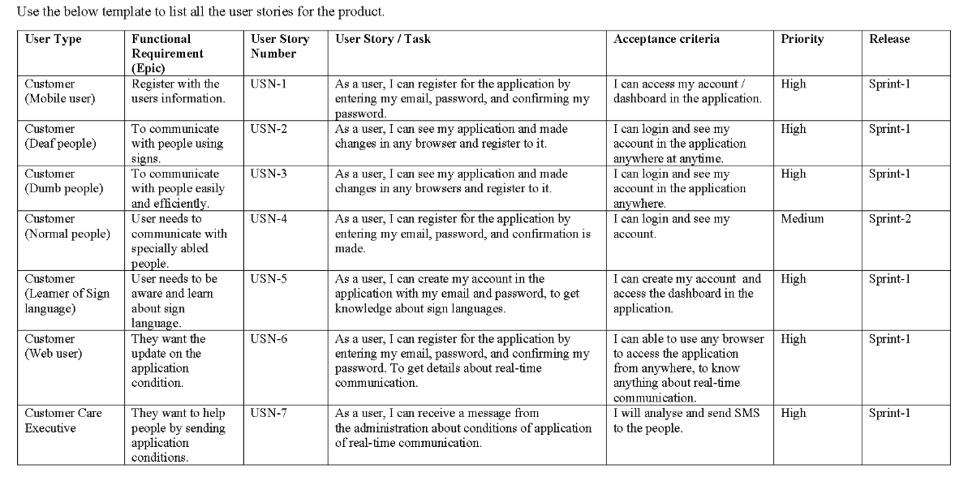

1. **Coding, Solutioning and Testing**

**Model Training for Real Time Communication through AI for Specially Abled**

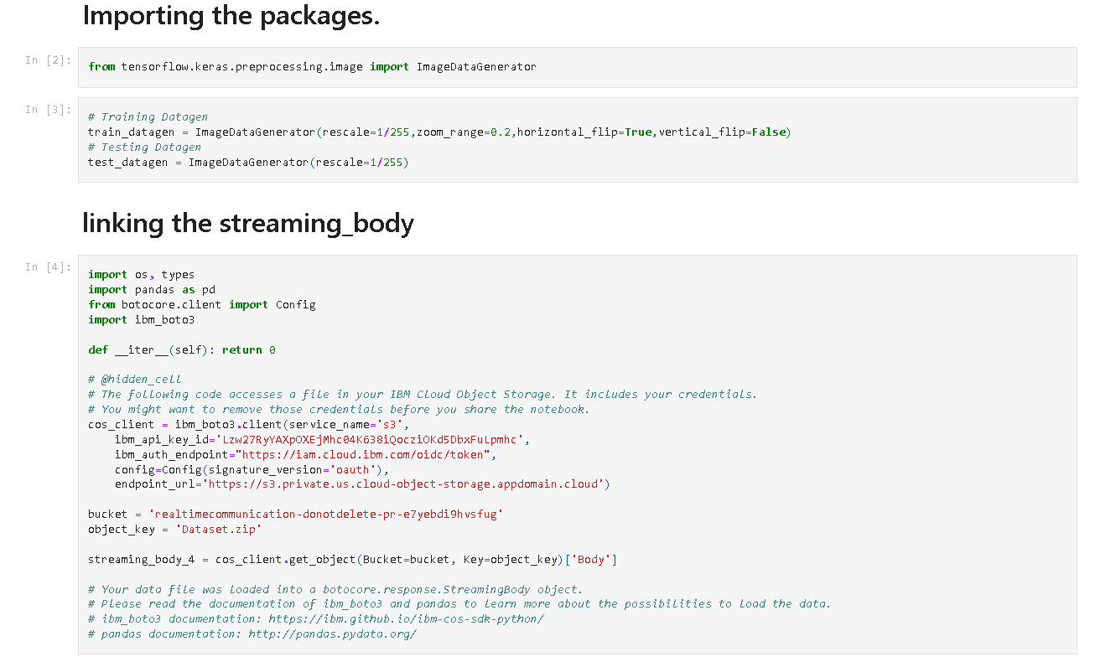

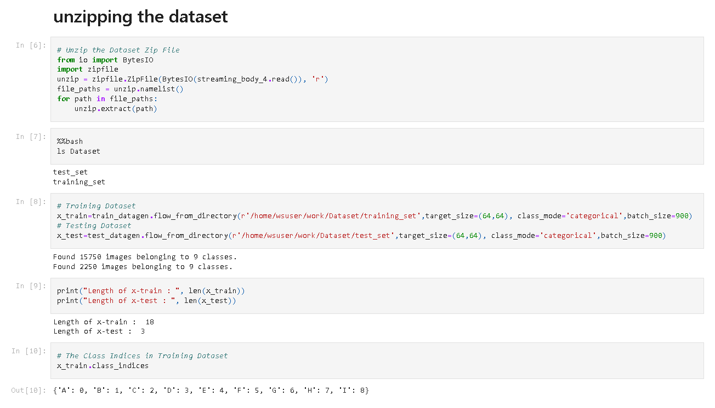

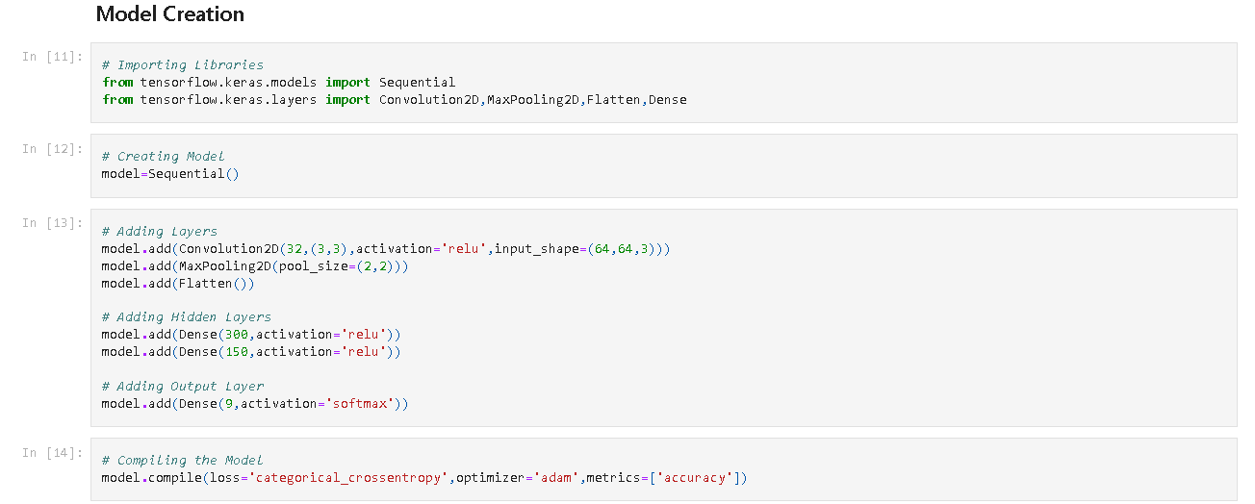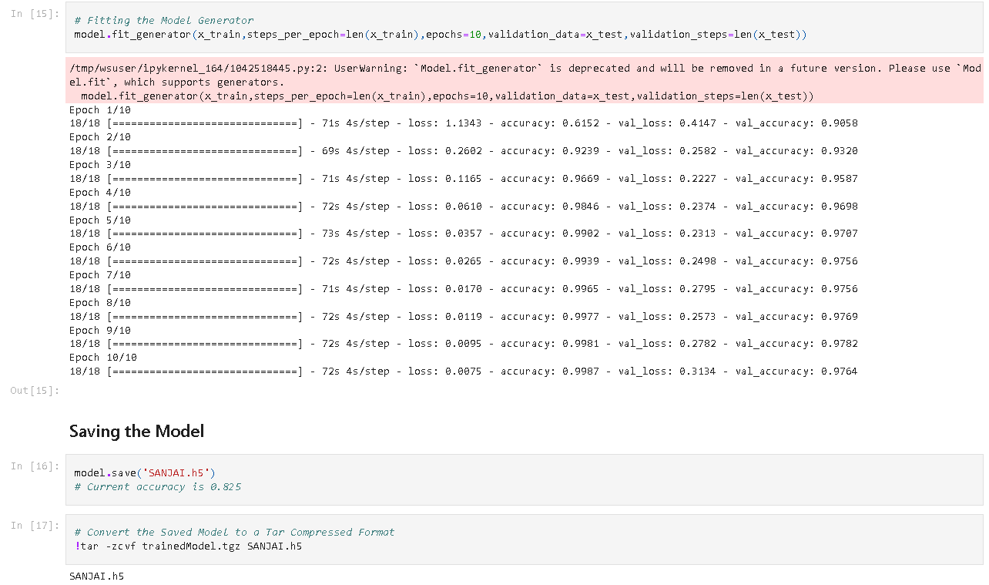

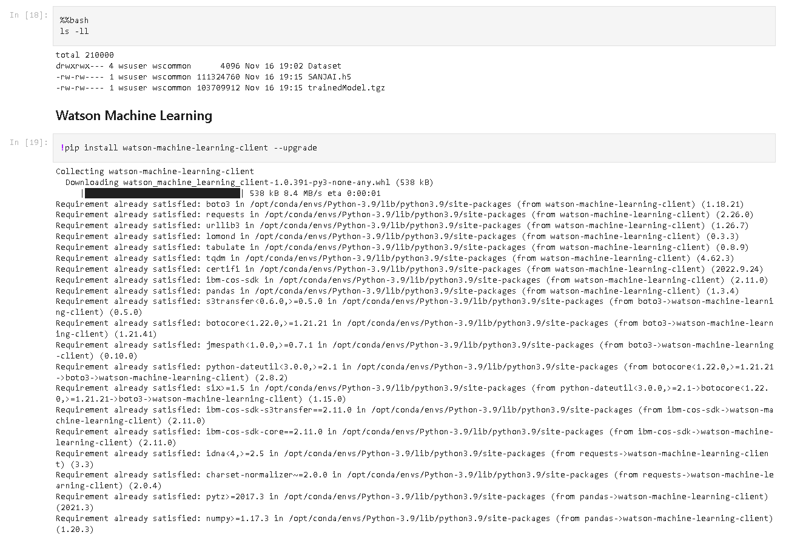

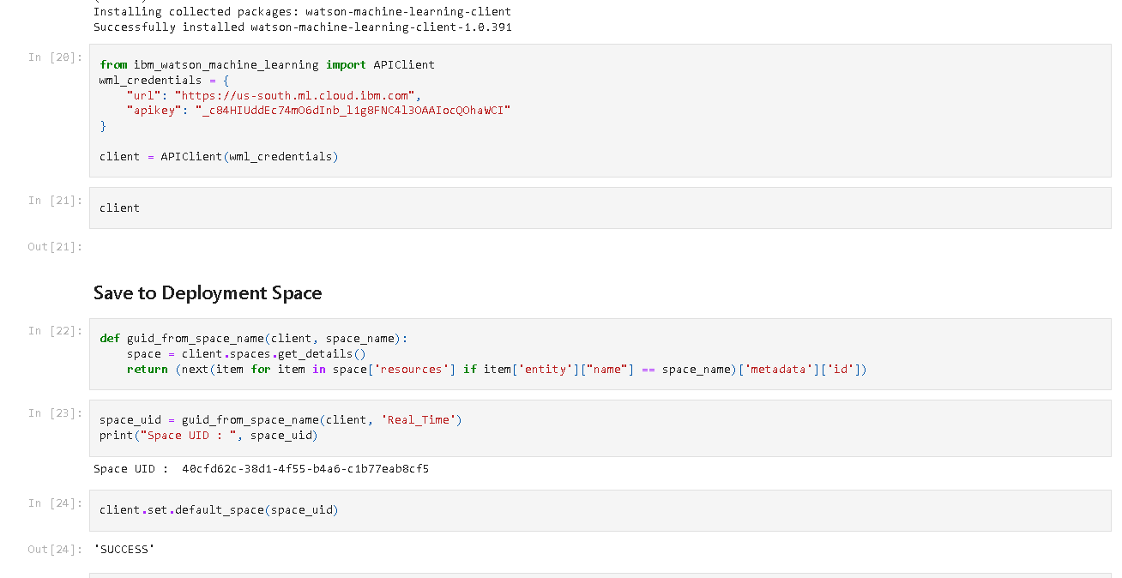

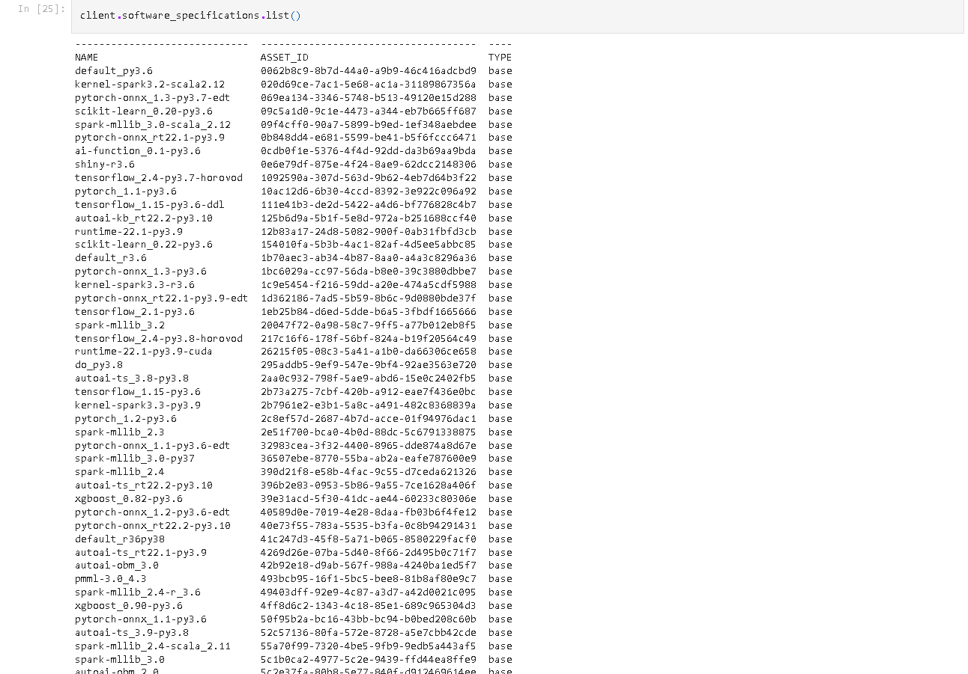

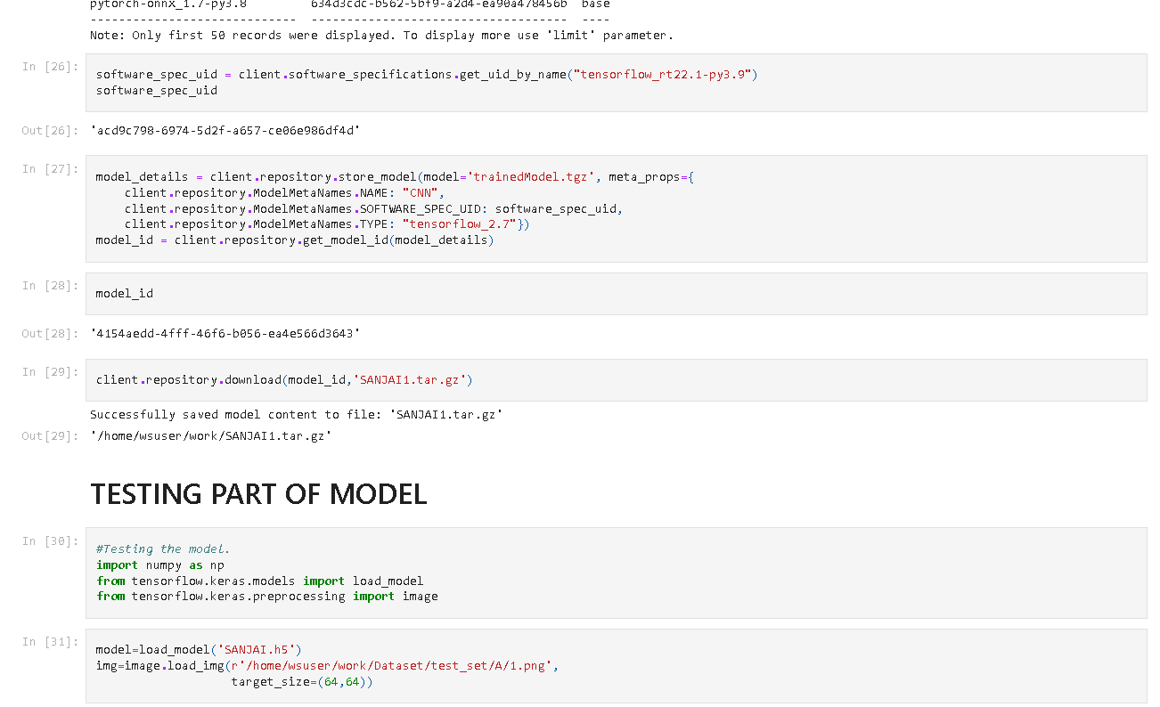

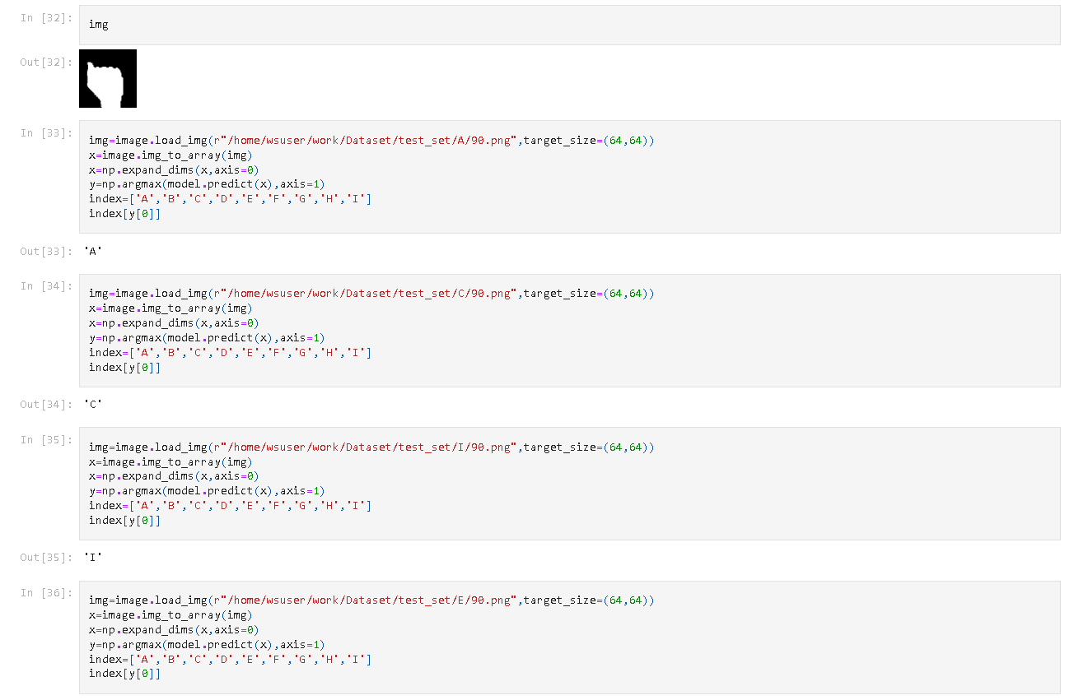

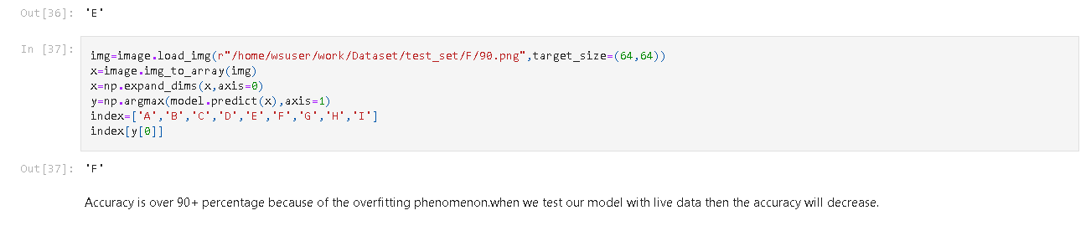

Spyder Deployment Code

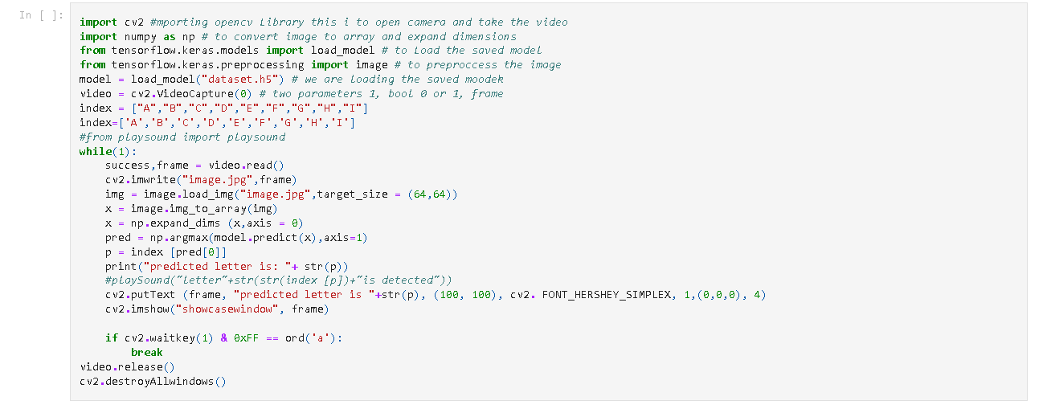

1. **Result**

A series of photos were used to implement and test the suggested approach. A collection of 2250 photos of the alphabet from "A" to "I" are utilised for the testing database, while a set of 15750 images are used for the training database.

The corresponding Alphabets are displayed on the screen as soon as the motion is recognised.

Snapshots of our model predicting the hand gestures are shown below :

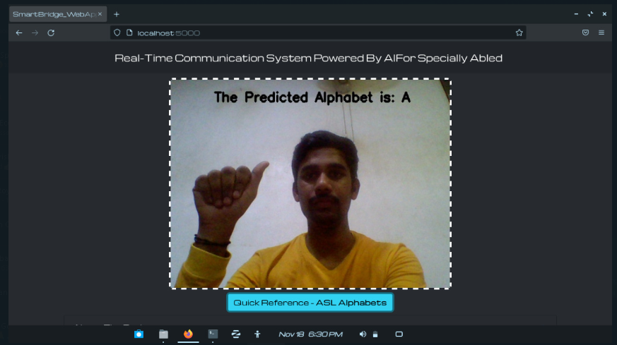

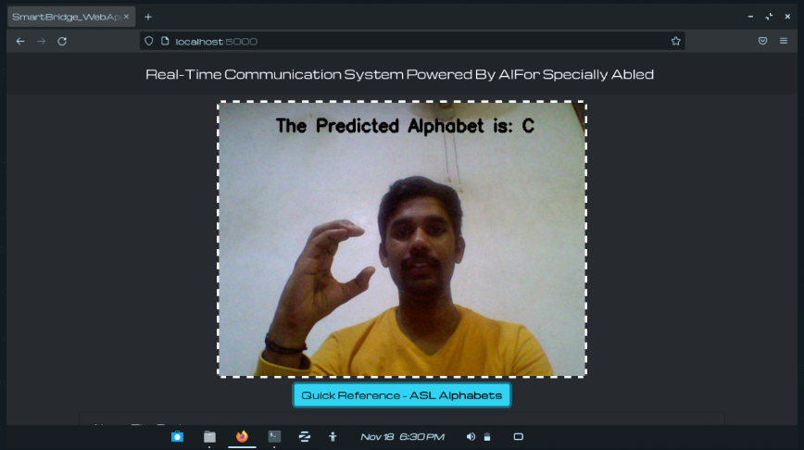

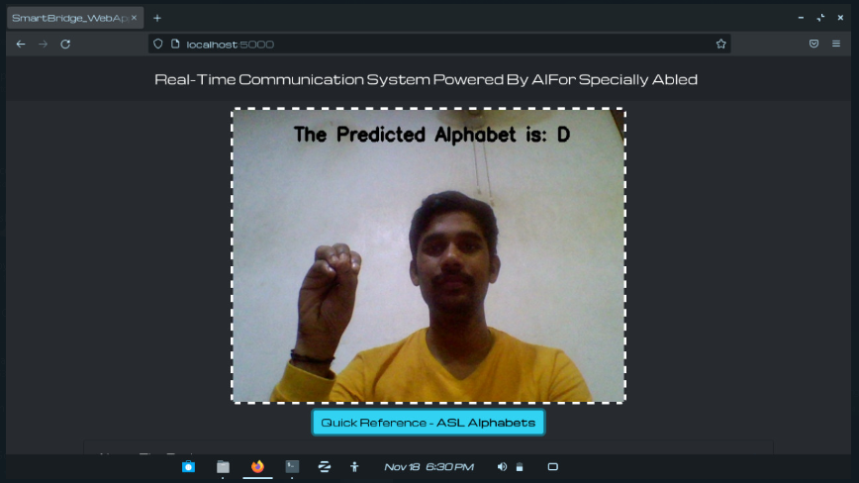

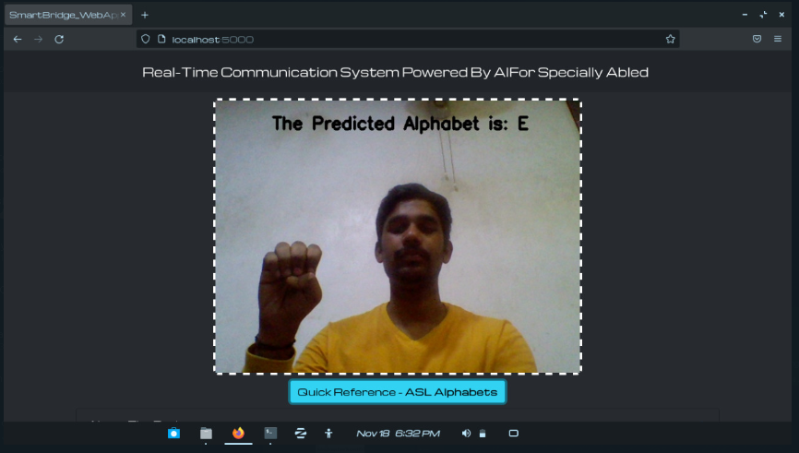

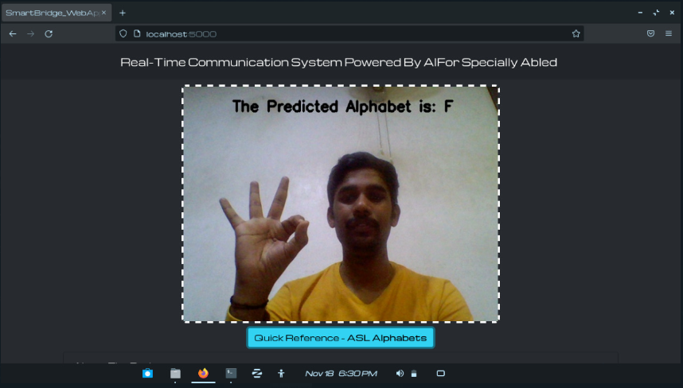

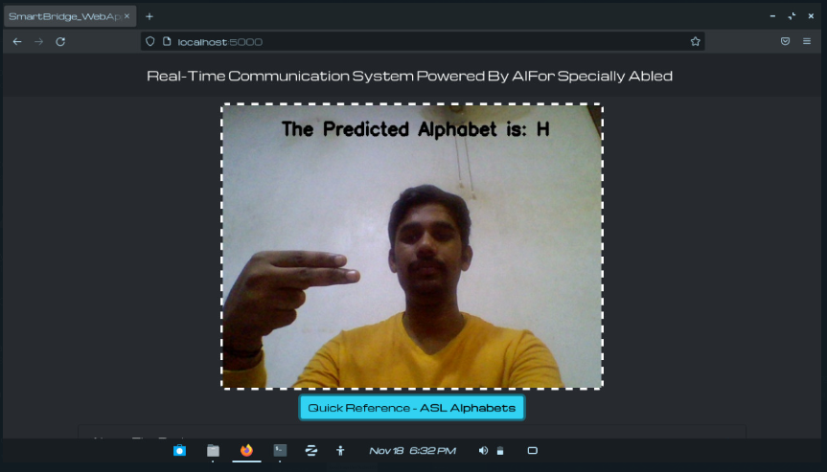

1. **Advantages and Disadvantages :**

**Advantages:**

1. It is feasible to develop a mobile application to close the communication gap between the hearing-impaired and the rest of society.

2. The user may select which sign language to read by adding the dataset when new sign language standards are created.

3. The disabled people who have hearing impairment will not have to be socially anxious anymore. They can communicate with great confidence

**Disadvantages:**

1. The present model is limited to the letters A through I.

2. Alphabets from J cannot be recognised in the absence of gesture recognition because they need user input in the form of a gesture.

3. The accuracy isn't excellent because there aren't many or high-quality photographs in the dataset, but that can be fixed by changing the datas.

1. **Conclusion :**

The use of sign languages can help normal and deaf individuals communicate more effectively.

Our approach strives to reduce the communication gap between the deaf community and the rest of society since it supports two-way conversation.

Our suggested technology converts sign languages into human-understandable English language.

With the help of this technology, the model receives hand gestures, recognises them, and then shows the corresponding Alphabet on the screen.

This initiative allows deaf-mute persons to perform sign language with their hands, which will later be translated into alphabets.

1. **Future Scope :**

For persons with particular needs, such as the deaf and dumb, having technology that can convert hand sign language to its appropriate alphabet is a game changer. The web programme may easily be developed to detect letters other than "I," numbers, and other symbols with the addition of gesture recognition. Gesture recognition can also be used to control software and hardware interfaces.

1. **References**

[1] Keras Image Processing Doc :- https://keras.io/api/preprocessing/image/

[2] Keras ImageDataset From Directory Doc :- https://keras.io/api/preprocessing/image/#imagedatasetfromdirectory-function

[3] CNN using Tensorflow :- https://www.youtube.com/watch?v=umGJ30-15_A

[4] OpenCV Basics of Processing Image :- https://www.youtube.com/watch?v=mjKd1Tzl70I

[5] Flask Basics :- https://www.youtube.com/watch?v=lj4I_CvBnt0

[6] IBM Academic Partner Account Creation :- https://www.youtube.com/watch?v=x6i43M7BAqE

[7] CNN Deployment and Download through IBM Cloud :- https://www.youtube.com/watch?v=BzouqMGJ41k

[8] Matusiak, K., Skulimowski, P., & Strurniłło, P. (2013, June). Object recognition in a mobile phone

application for visually impaired users. In 2013 6th International Conference on Human System

Interactions (HSI) (pp. 479-484). IEEE

.

[9] Hermus, K., & Wambacq, P. (2006). A review of signal subspace speech enhancement and its application

to noise robust speech recognition. EURASIP Journal on Advances in Signal Processing, 2007(1), 045821.

[10] Dimitrov, V., Jullien, G., & Muscedere, R. (2017). Multiple-base number system: theory and applications.

CRC press.

.

[11] Huyan, Z., Xu, L., Fang, S., Liu, Z., Zhang, X., & Li, L. (2014). Field information acquisition system

research based on offline speech recognition. Int. J. Database Theory Appl, 7, 45-58.

[12] Bigham, J. P., Jayant, C., Miller, A., White, B., & Yeh, T. (2010, June). VizWiz:: LocateIt-enabling blind people to locate objects in their environment. In 2010 IEEE Computer Society Conference on Computer

Vision and Pattern Recognition-Workshops (pp. 65-72). IEEE.

[13] Manduchi, R., Kurniawan, S., & Bagherinia, H. (2010, October). Blind guidance using mobile computer

vision: A usability study. In Proceedings of the 12th international ACM SIGACCESS conference on

Computers and accessibility (pp. 241-242).

[14] Ivanchenko, V., Coughlan, J., Gerrey, W., & Shen, H. (2008, October). Computer vision-based clear path

guidance for blind wheelchair users. In Proceedings of the 10th international ACM SIGACCESS

conference on Computers and accessibility (pp. 291-292).

[15] Johnsen, A., Grønli, T. M., & Bygstad, B. (2012). Making touch-based mobile phones accessible for the

visually impaired. Norsk informatikkonferanse,(Bodø, Norway, 2012).

[16] Jiang, R., Lin, Q., & Qu, S. (2016). Let Blind People See: Real-Time Visual Recognition with Results

Converted to 3D Audio. Report No. 218, Standord University, Stanford, USA.

[17] Kamble, K., & Kagalkar, R. (2014). A review: translation of text to speech conversion for Hindi

language. International Journal of Science and Research (IJSR) Volume, 3.

[18] Kumar, A., & Chourasia, A. (2018). Blind Navigation System Using Artificial Intelligence. International

Research Journal of Engineering and Technology, 5(3).

[19] BELGHIT, H., & BELLARBI, A. Object Recognition Based on ORB Descriptor for Markerless

Augmented Reality.

[20] Coughlan, J., & Manduchi, R. (2009). Functional assessment of a camera phone-based wayfinding system operated by blind and visually impaired users. International Journal on Artificial Intelligence

Tools, 18(03), 379-397.

[21] Chen, C., & Raman, T. V. (2009). Announcing eyes-free shell for Android. Retrieved December, 21, 2016.

[22] Gill, J. (2000). Personal electronic mobility devices. Information for Professionals Working with Visually

Disabled People. http://www. tiresias. org.

[23] Coughlan, J., & Manduchi, R. (2007). Color targets: Fiducials to help visually impaired people find their

way by camera phone. EURASIP Journal on Image and Video Processing, 2007, 1-13.

[24]Arora, S. J., & Singh, R. P. (2012). Automatic speech recognition: a review. International Journal of

Computer Applications, 60(9).

[25] Omankhanlen, A. E., & Ogaga-Oghene, J. (2013). The Dynamics of Global Strategy and Strategic

Alliances in International Trade and Investment. INTERNATIONAL JOURNAL OF RESEARCH IN

COMPUTER APPLICATION & MANAGEMENT, 3(12), 41-48.

[[26]](https://www.researchgate.net/publication/263329750_A_Model_for_Real-Time_Recognition_and_Textual_Representation_of_Malaysian_Sign_Language_through_Image_Processing)[**(PDF) A Model for Real-Time Recognition and Textual Representation of Malaysian Sign Language through Image Processing (researchgate.net)**](https://www.researchgate.net/publication/263329750_A_Model_for_Real-Time_Recognition_and_Textual_Representation_of_Malaysian_Sign_Language_through_Image_Processing)

1. **Appendix :**

* **Source code for model building**

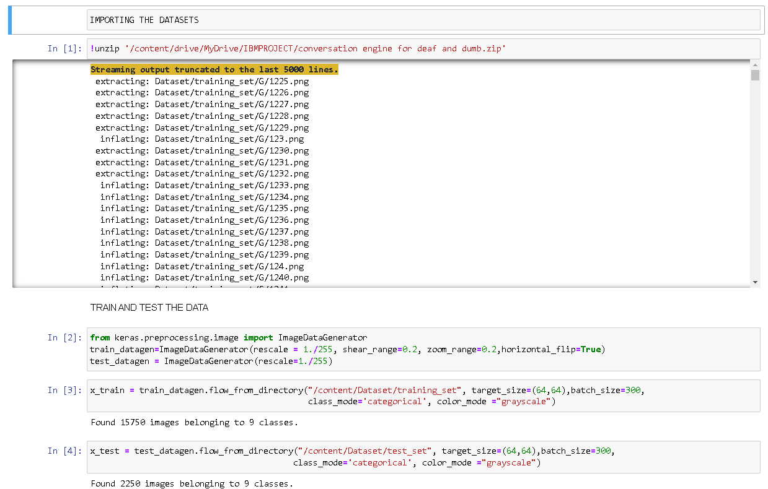

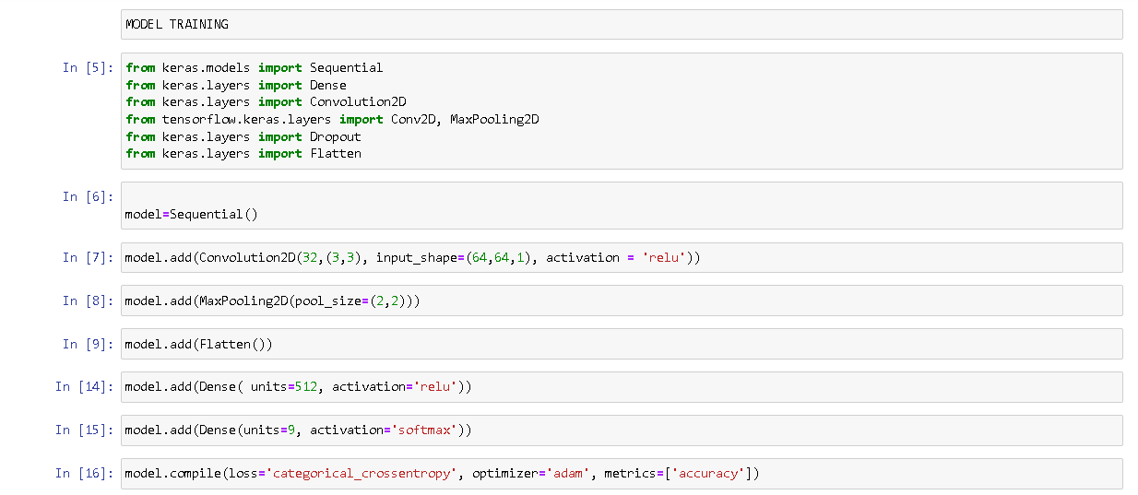

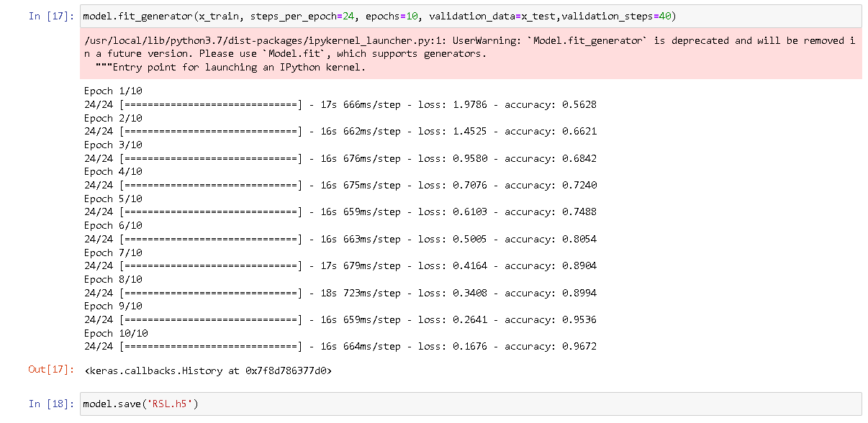

* **Github link :** [**https://github.com/IBM-EPBL/IBM-Project-1855-1658418245**](https://github.com/IBM-EPBL/IBM-Project-1855-1658418245)
* **Project demo link :**

[**https://youtu.be/6MU_YC6KWE8**](https://youtu.be/6MU_YC6KWE8)

### 

# 